Task 2 Report: Interactive JavaScript To-Do List Application
1. Task Title
Interactive To-Do List Application using JavaScript DOM Manipulation

2. Objective
To design and develop an interactive To-Do List web application using HTML, CSS, and JavaScript.
The main objective of this project is to create a user-friendly task management application where users can add, view, complete, and delete tasks dynamically using JavaScript DOM manipulation.

3. Technologies Used
• HTML5
• CSS3
• JavaScript (ES6)
• DOM Manipulation
• Git
• GitHub

4. Project Description
This project is a mini interactive task management application developed using HTML, CSS, and JavaScript.
The application allows users to manage their daily tasks by adding task names along with due dates. JavaScript is used to dynamically update the webpage whenever a task is added, completed, or deleted.
The website contains:
• Add task functionality
• Due date selection
• Dynamic task display
• Task completion tracking
• Delete task option
• Responsive user interface
• Interactive buttons and hover effects

5. Application Screenshots
Homepage Screenshot
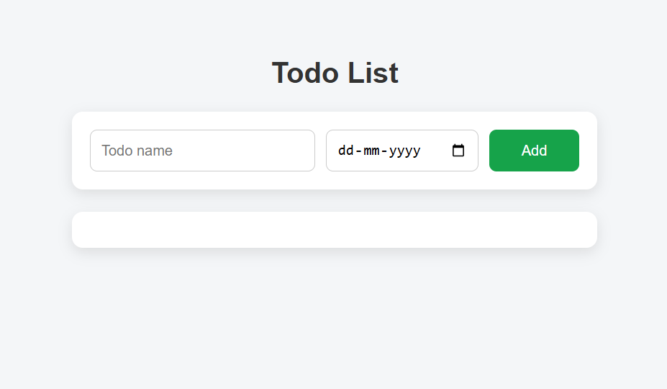
Task Added Screenshot
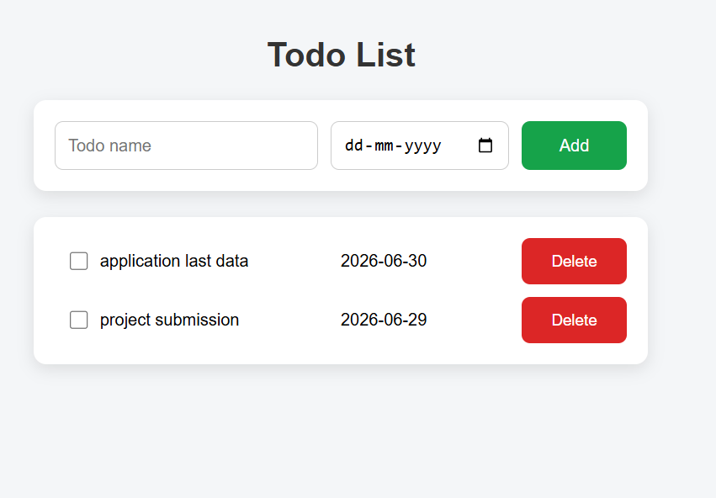
Completed Task Screenshot
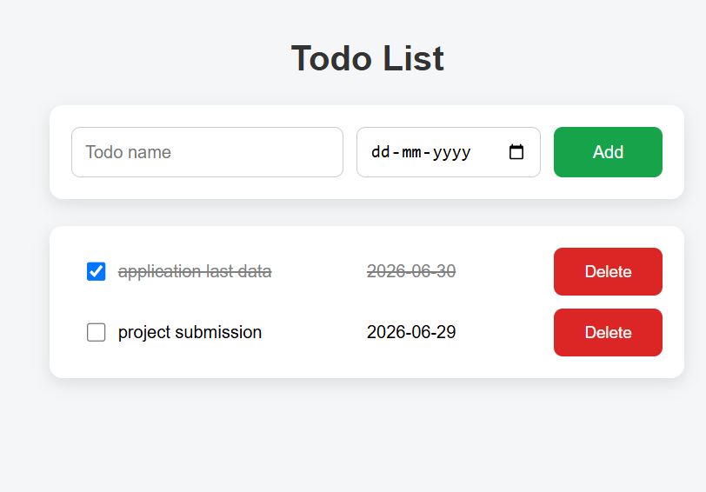

6. Code Snippets
HTML Code
<!DOCTYPE html>
<html>
<head>
<title>Todo List</title>
<link rel="stylesheet" href="style.css">
</head>
<body>
<p>Todo List</p>
<div class="todo-input-grid">
<input class="js-name-input name-input" placeholder="Todo name">
<input type="date" class="js-due-date-input due-date-input">
<button onclick="addTodo()" class="add-todo-button">
Add
</button>
</div>
<div class="js-todo-list todo-grid"></div>
<script src="script.js"></script>
</body>
</html>

JavaScript Code
const todoList = [
{
name: 'make dinner',
dueDate: '2022-12-22',
completed: false
},
{
name: 'wash dishes',
dueDate: '2022-12-22',
completed: false
}
];
renderTodoList();
function renderTodoList() {
let todoListHTML = '';
for (let i = 0; i < todoList.length; i++) {
const todoObject = todoList[i];
const { name, dueDate, completed } = todoObject;
const completedClass = completed ? "completed" : "";
const html = `
<div class="${completedClass}">
<input type="checkbox"
${completed ? "checked" : ""}
onclick="
toggleComplete(${i});
"
>
${name}
</div>
<div class="${completedClass}">
${dueDate}
</div>
<button onclick="
deleteTodo(${i});
" class="delete-todo-button">
Delete
</button>
`;
todoListHTML += html;
}
document.querySelector('.js-todo-list')
.innerHTML = todoListHTML;
}
function addTodo() {
const inputElement = document.querySelector(
'.js-name-input'
);
const name = inputElement.value;
const dateInputElement = document.querySelector(
'.js-due-date-input'
);
const dueDate = dateInputElement.value;
if (name === '') {
alert("Please enter a todo");
return;
}
todoList.push({
name: name,
dueDate: dueDate,
completed: false
});
inputElement.value = '';
dateInputElement.value = '';
renderTodoList();
}
function deleteTodo(index) {
todoList.splice(index, 1);
renderTodoList();
}
function toggleComplete(index) {
todoList[index].completed =
!todoList[index].completed;
renderTodoList();
}
document.querySelector('.js-name-input')
.addEventListener('keydown', function (event) {
if (event.key === "Enter") {
addTodo();
}
});

CSS Code
const todoList = [
{
name: 'make dinner',
dueDate: '2022-12-22',
completed: false
},
{
name: 'wash dishes',
dueDate: '2022-12-22',
completed: false
}
];
renderTodoList();
function renderTodoList() {
let todoListHTML = '';
for (let i = 0; i < todoList.length; i++) {
const todoObject = todoList[i];
const { name, dueDate, completed } = todoObject;
const completedClass = completed ? "completed" : "";
const html = `
<div class="${completedClass}">
<input type="checkbox"
${completed ? "checked" : ""}
onclick="
toggleComplete(${i});
"
>
${name}
</div>
<div class="${completedClass}">
${dueDate}
</div>
<button onclick="
deleteTodo(${i});
" class="delete-todo-button">
Delete
</button>
`;
todoListHTML += html;
}
document.querySelector('.js-todo-list')
.innerHTML = todoListHTML;
}
function addTodo() {
const inputElement = document.querySelector(
'.js-name-input'
);
const name = inputElement.value;
const dateInputElement = document.querySelector(
'.js-due-date-input'
);
const dueDate = dateInputElement.value;
if (name === '') {
alert("Please enter a todo");
return;
}
todoList.push({
name: name,
dueDate: dueDate,
completed: false
});
inputElement.value = '';
dateInputElement.value = '';
renderTodoList();
}
function deleteTodo(index) {
todoList.splice(index, 1);
renderTodoList();
}
function toggleComplete(index) {
todoList[index].completed =
!todoList[index].completed;
renderTodoList();
}
document.querySelector('.js-name-input')
.addEventListener('keydown', function (event) {
if (event.key === "Enter") {
addTodo();
}
});

7. Features Implemented
Add Task
Users can enter a task name and select a due date to create a new task.
Dynamic Display
Tasks are displayed instantly without refreshing the webpage using DOM manipulation.
Task Completion
Users can mark completed tasks using a checkbox.
Delete Task
Users can remove unwanted tasks from the task list.
Responsive Design
The application adjusts according to different screen sizes.

8. GitHub Repository Link
Add your repository link:
https://github.com/saideepika-29/InternSpark_Internship_task-2_ToDoList
9. Hosted Website Link
GitHub Pages Link:
https://saideepika-29.github.io/InternSpark_Internship_task-2_ToDoList//
10. Conclusion
The Interactive To-Do List Application was successfully developed using HTML, CSS, and JavaScript.
This project demonstrates practical implementation of JavaScript concepts such as DOM manipulation, event handling, arrays, objects, and dynamic webpage updates.
The application provides a simple and effective way for users to manage their daily tasks.

11. Author
Deepika
GitHub:
https://github.com/saideepika-29

